# Name of Your Company:

The name of the company is Child Care Limited (i.e., Babysitting Company)

# Project Title:

Database for a company that provides babysitting services to families.

# Team:

* + Emilia Hoang (MS SQL Server Expert)

o Contact No. - +84938621938

o WhatsApp No – +84938621938

* + - Email Id – Emilia Hoang – [hoangn8@student.dougalscollege.ca](mailto:hoangn8@student.dougalscollege.ca)
  + Simran Saini (MySQL Expert)

o Contact No. - 7788680151

* + - WhatsApp No – 7785126656
    - Email Id – [sainis16@student.dougalscollege.ca](mailto:sainis16@student.dougalscollege.ca)

# Weekly Meeting Hours:

We will meet and work on the project every Wednesday from 3:30 pm to 5:30 pm.

# Project Description:

* + The database store data about babysitters, families, and details of contracts between them.
  + Data about babysitters - managers: name, date of birth, highest education degree, skills (painting, singing, playing guitar, standup comedy…), availability time (days of week, from-to time, …), gender, occupation (babysitting can be the second job of the person), SSN, nationality, languages that the person can speak….
  + Data about parents: full name of the family representative, address, phones, emails, marital status (married, divorced,

single parent…)

* + Data about the child that needs babysitting: name, date of birth, age, gender, disability (if the child has any), languages

spoken…

* + Data about contract: start and end date, the schedule of babysitting (time and activity done during that time), services

expected from babysitter…

# Assumptions about Cardinality and Participations:

1. Babysitters sign contract: **SIGN** relationship (between BABYSITTER, CONTRACT) Many-to-many (1:N) Total participation (All babysitters sign at least 1 contract; all contracts are signed by at least 1 babysitter).
2. Children are part of contract: **BE_PART_OF** relationship (between CHILDREN, CONTRACT by weak entity we find who the parent is) One-to-many (1:N)

Partial participation (Not all contracts are signed; all children sign at least 1 contract)

1. Manager manages babysitter: **MANAGEMENT** recursive relationship (between Manager, Babysitter) One-to-many (1:N).
2. Parents have children: **HAVE** relationship (between PARENT, CHILDREN) One-to-many (1:N)

Total participation (All parents have at least 1 child; all children have at least 1 parent).

SCREENSHOTS:

MS SQL:

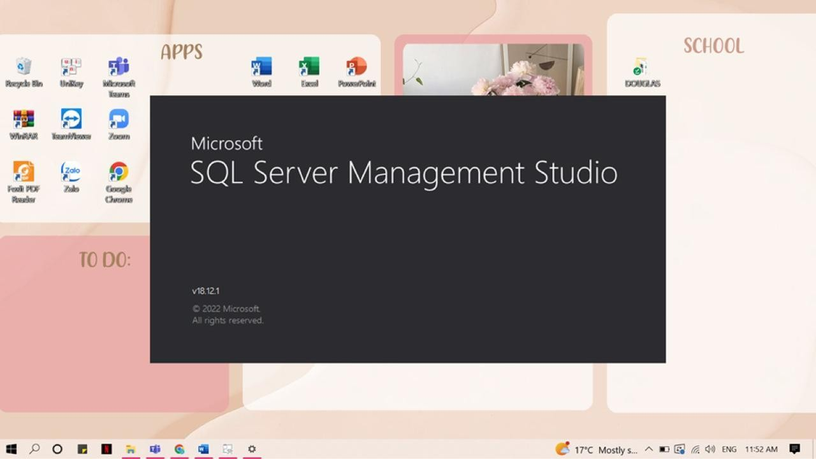

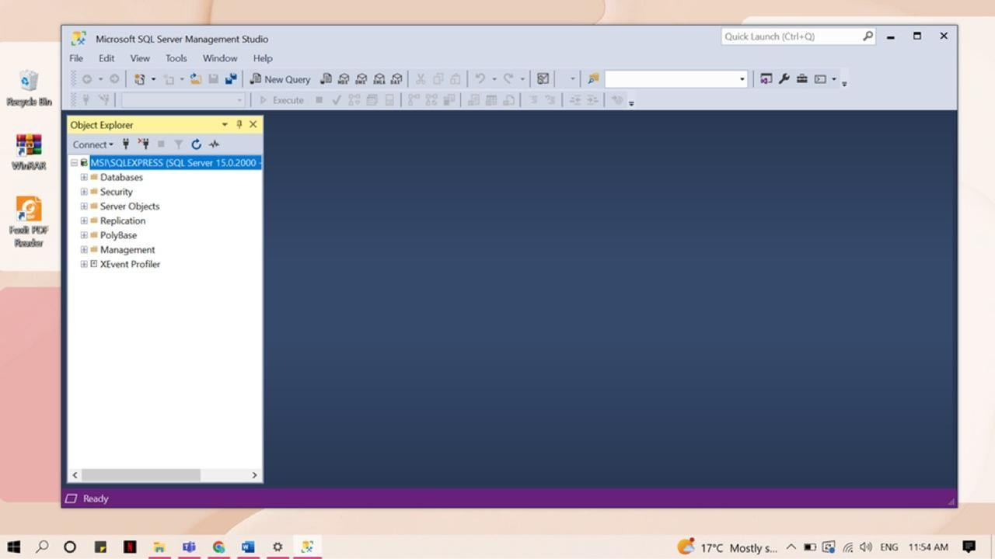

MySQL:

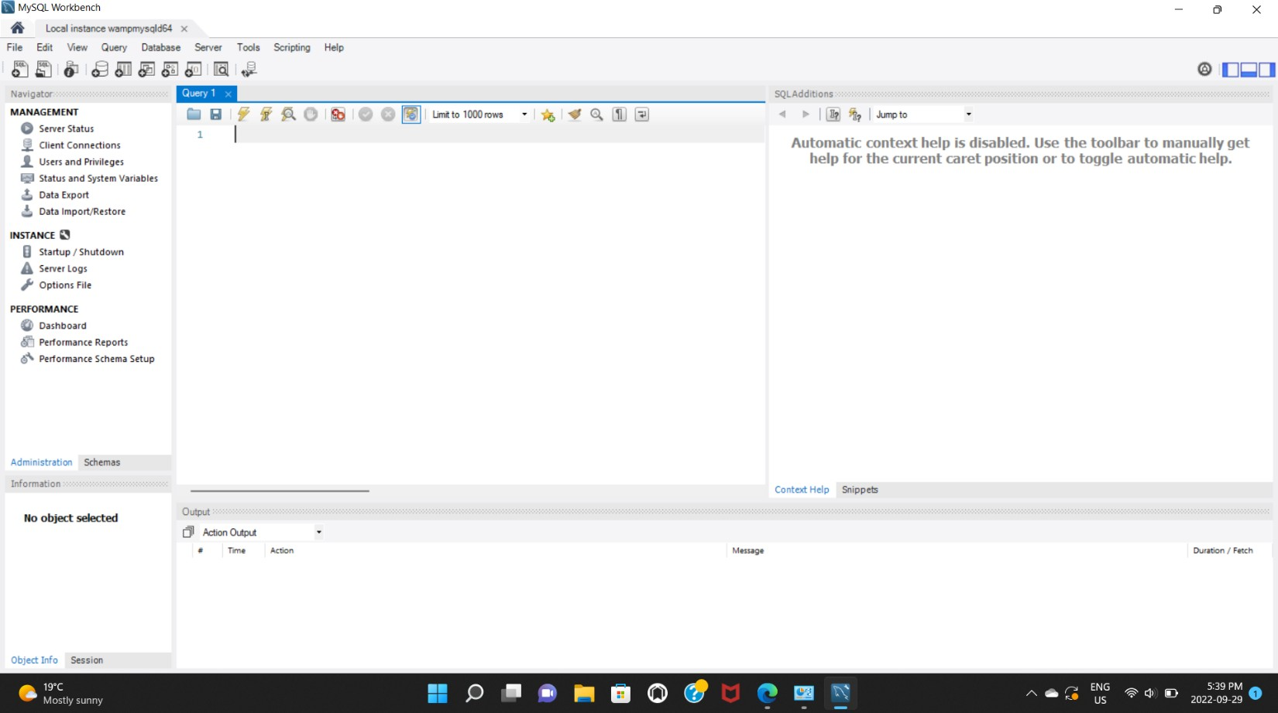

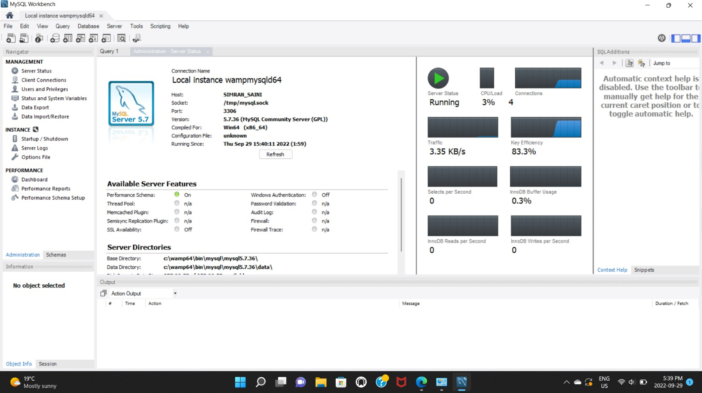

# EER Modeling Diagram

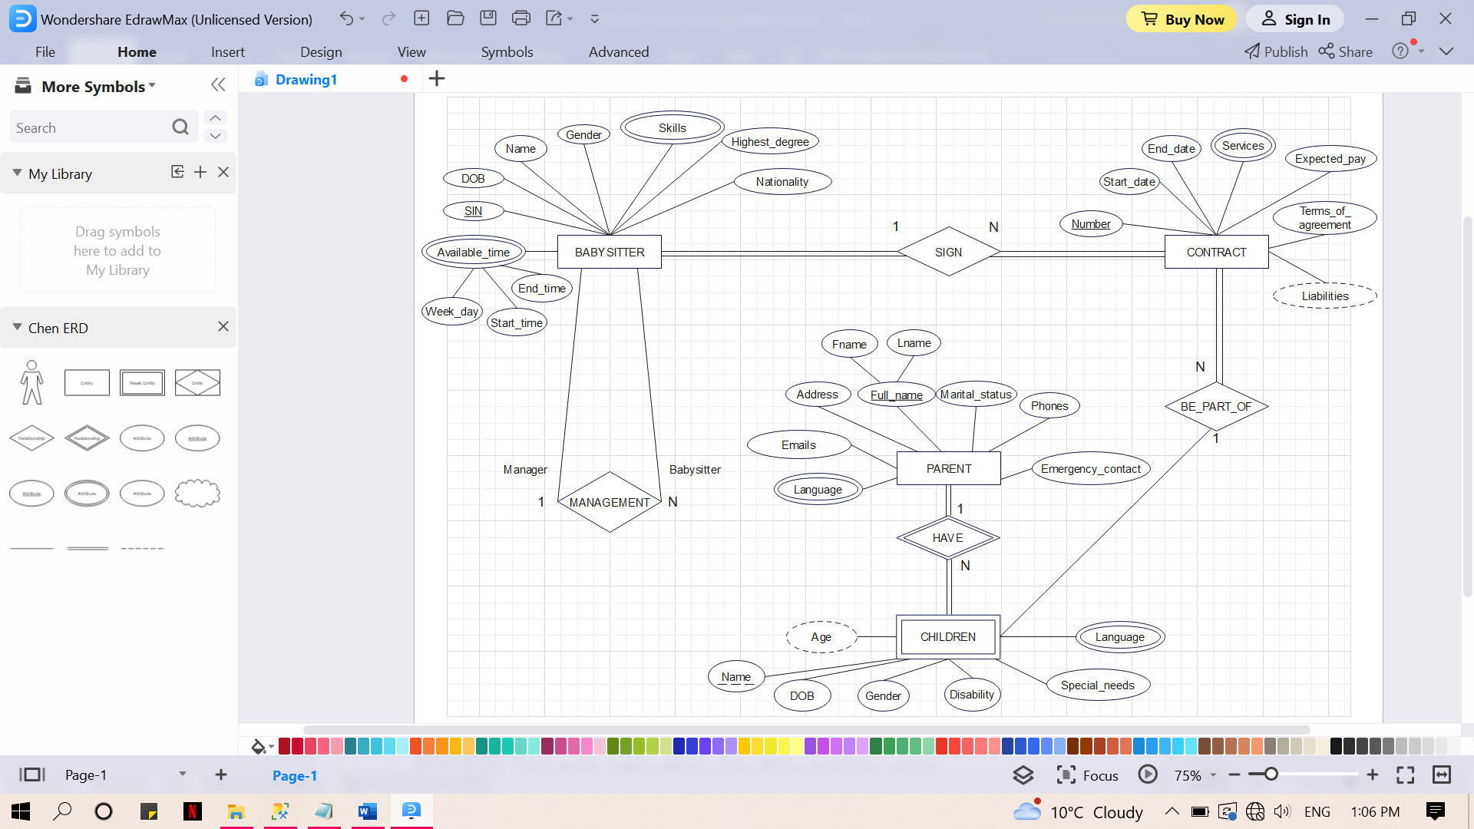

# ER-Model Mapping to Database Relational Schema

1. Map strong entity:

Parent (Fname, Lname, Emails, Address, Marital_status, Phones, Emergency_contact)

Contract (Number, Start_date, End_date, Expected_pay, Terms_of_aggreement)

Babysitter (SIN, DOB, Name, Gender, Highest_degree, Nationality)

1. Map weak entity:

Children ((**Fname, Lname),** Child_name, DOB, Gender, Disability, Special_needs)

1. Map relationship:

HAVE relationship: do not need to map identifying relationship

BE_PART_OF relationship: using relational relation

Children_BePartOf_Contract (**Contract_Number**, **(Fname, Lname), Child_name)**

SIGN relationship: put the key of Babysitters to become foreign key of Contract

Contract (Number, Name_of_child, Start_date, End_date, Expected_pay, Terms_of_aggreement, **Babysitter**_**SIN**)

MANAGEMENT relationship: recursive, partial -> use relationship relation

Manager_Babysitter (**Manager_SIN, Babysitter_SIN**)

1. Map multivalued attributes:

Parent_Language ((**Fname, Lname**), Language)

Contract_Service (**Contract_number**, Services)

Children_Language (**Fname, Lname), Child_name**, Language)

Babysitter_AvailableTime (**SIN**, Start_time, End_time, Week_day)

Babysitter_Skills (**SIN**, Skills)

1. Combined all relations:

Parent (Fname, Lname, Emails, Address, Marital_status, Phones, Emergency_contact)

Contract (Number, Start_date, End_date, Expected_pay, Terms_of_aggreement, **Babysitter**_**SIN**)

Babysitter (SIN, DOB, Name, Gender, Highest_degree, Nationality)

Children ((**Fname, Lname),** Child_name, DOB, Gender, Disability, Special_needs)

Children_BePartOf_Contract (**Contract_Number**, **(Fname, Lname), Child_name)**

Manager_Babysitter (**Manager_SIN, Babysitter_SIN**)

Parent_Language ((**Fname, Lname**), Language)

Contract_Service (**Contract_number**, Services)

Children_Language (**Fname, Lname, Child_name**, Language)

Babysitter_AvailableTime (**SIN**, Start_time, End_time, Week_day)

Babysitter_Skills (**SIN**, Skills)

# Normalization

1NF: There is no multivalued attributes in the schema

2NF: Every non-prime attribute in schema is fully functionally dependent on the primary key

3NF: There is no transitive FD in the schema

The model is completely in the 3NF normalization.